**Testing Telecom Domain with Sample OSS/BSS Test cases**

### **What is Telecom Testing?**

Telecom Testing is defined as the testing of Telecommunication software. Since the shift of the telecom sector to digital and computer networks, telecommunication industry uses software indispensable. Telecom sector depends on the various types of software components to deliver many services like routing and switching, VoIP broadband access, etc. Hence, telecom software testing is inevitable.

**Table of Content:**

* [What is Domain in Testing?](https://www.guru99.com/testing-telecom-application-with-sample-testcases.html#what-is-domain-in-testing)
* [Why Testing Domain Knowledge Matters?](https://www.guru99.com/testing-telecom-application-with-sample-testcases.html#why-testing-domain-knowledge-matters)
* [Business Processes in the Telecom Industry](https://www.guru99.com/testing-telecom-application-with-sample-testcases.html#business-processes-in-the-telecom-industry)
* [Typical Telecom Business Process](https://www.guru99.com/testing-telecom-application-with-sample-testcases.html#typical-telecom-business-process)
* [Types of Protocols used in Telecom Industry](https://www.guru99.com/testing-telecom-application-with-sample-testcases.html#types-of-protocols-used-in-telecom-industry)
* [Testing LifeCycle in the Telecom Industry](https://www.guru99.com/testing-telecom-application-with-sample-testcases.html#testing-lifecycle-in-the-telecom-industry)
* [Types of Testing Performed on Telecom Software](https://www.guru99.com/testing-telecom-application-with-sample-testcases.html#types-of-testing-performed-on-telecom-software)
* [Sample TestCases for Telecom Testing](https://www.guru99.com/testing-telecom-application-with-sample-testcases.html#sample-testcases-for-telecom-testing)
* [Summary](https://www.guru99.com/testing-telecom-application-with-sample-testcases.html#summary)

## What is Domain in Testing?

A domain is nothing but the industry for which the software testing project is created. When we talk about software project or development, this term is often referred. For example, the Insurance domain, Banking domain, Retail Domain, Telecom Domain, etc.



Usually while developing any specific domain project, domain expert help is sought out. Domain expert is master of the subject and he may know the inside-out of the product or application.

## Why Testing Domain Knowledge Matters?

Domain knowledge is quintessential for testing any software product, and it has its own benefits like

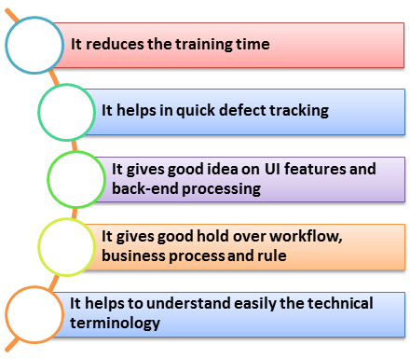

## Business Processes in the Telecom Industry

For telecom testing end-to-end service verification is important. To ensure efficient testing a good understanding of the different Business process is a must.

You need to understand each stage of service deliverability before drafting the test cases.

Telecom services are either based on a business support system that includes IVR’s, Call Centers, generating invoices, etc. or an operation support system that includes routers, switches, cell towers, etc.

The following table shows what activities are performed at different levels

|  |  |
| --- | --- |
| **Telecom Department** | **Telecom Activities** |
| Pre-sales | * It handles all the sales information like discounts, services, promos, etc. |
| Ordering | * Applying for a new connection or disconnecting a connection |
| Provisioning | * This division deals with the physical connection between customers and TSP ( Telecom Service Provider) |
| Billing | * Under this division, all billing work is done |
| Service Assurance | * In case of any failure, this division corrects the problem |
| Inventory Systems | * It is the repository of all information |
| Tracking | * This division tracks the ordering system and the status of an order |

## Typical Telecom Business Process

Following is a typical business process in the Telecom Industry.

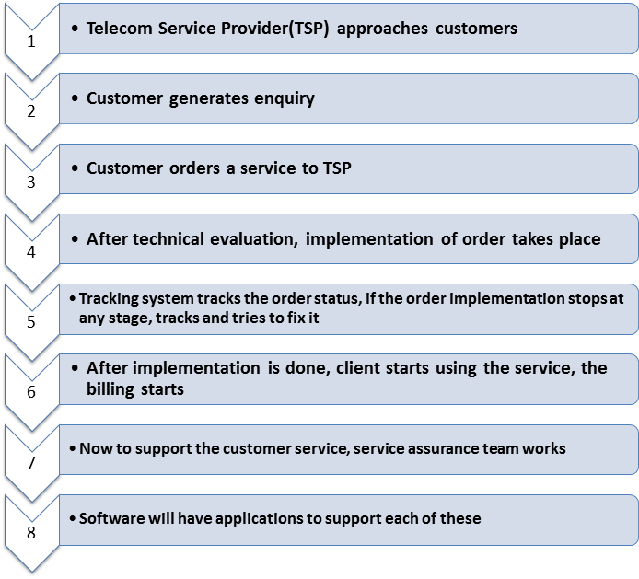

## Types of Protocols used in Telecom Industry

Here the popular protocols used in the Telecom industry

* **VoIP technologies**: VoIP, IMS, MPLS, ISDN, PSTN
* **Signaling and Protocols**: SIP, ISDN, Codecs, H.323
* **Wireless technologies:**GPRS, CDMA, GSM, UMTS
* **Network Management:**SNMP
* **Layer 2 Protocols:**ARP, STP, L2TP, PPP
* **Layer 3 protocols/routing:**ICMP, BGP, ISIS, MPLS
* **Infrastructure/Security:**ATM, TCP/IP, LAN/VLAN, SSH

**You can learn more about Protocol Testing**[**here**](https://www.guru99.com/protocol-testing.html)

## Testing LifeCycle in the Telecom Industry

The Test Lifecycle in the telecom industry is similar to that of any other industry but with a stress on details. Here is how the test lifecycle looks like along with the test artifacts.

|  |  |
| --- | --- |
| **Telecom Testing Stage** | **Test artifacts** |
| * Business View | * Requirement based test artifacts * Feasibility based artifacts * Standard and policy identification based test artifacts * Operation and maintenance considerations related test artifacts |
| * System/ Architecture | * System test artifacts (Security, Installation) * Test artifacts for virtual prototype * Special [System Testing](https://www.guru99.com/system-testing.html) artifacts ( interoperability, disaster recovery) |
| * Implementation | * Unit test artifacts * Integration test artifacts * Quality and performance artifacts * Regression, load testing, sanity, etc. |
| * Deployment | * Acceptance test artifacts * Integration test artifacts * Quality and performance artifacts * Functional test artifacts * Alpha/Beta test artifacts |

## Types of Testing Performed on Telecom Software

* Interconnection Testing
* Conformance Testing
* IVR Testing
* [Performance Testing](https://www.guru99.com/performance-testing.html)
* [Security Testing](https://www.guru99.com/what-is-security-testing.html)
* Interoperability Testing
* Protocol Testing
* Functional Testing
* [Automation Testing](https://www.guru99.com/automation-testing.html)

## Sample TestCases for Telecom Testing

In Telecom Testing, one must consider the testing following

|  |  |
| --- | --- |
| **Various Telecom Testing** | **Testing activities in Telecom** |
| **Billing System** | * Verify, the telephone number of the customer is registered under telecom operator * Verify whether the number is still working * Verify the number entered is valid, and it is 10 digit number * Verify the number is not blocked due to some reasons * Verify if the number has any outstanding bills, if exist, display it on screen * Verify the number has all previous accounts or bills cleared * Verify the system enables statement generation as per customer requirement * Verify the system has recorded a number of calls accurately * Verify the plan chosen by the customer displays on the billing system * Verify the total amount billed is accurate and mapped to the service offered |
| **Application Testing** | * Protocols, signaling, field testing for IOT * Usage and[Functional Testing](https://www.guru99.com/functional-testing.html) for core[Mobile](https://www.guru99.com/mobile-testing.html)handset applications like a call, SMS, transfer/hold, etc. * Testing of various applications like finance, sports and location-based services, etc. OSS-BSS testing |
| **OSS-BSS Testing** | * Billing, customer case, interconnect billing, order and fraud management, revenue assurance * Network management, mediation, provisioning, etc. * EAI, CRM & ERP, [data warehousing](https://www.guru99.com/data-warehousing.html), etc. |
| **Conformance Testing** | * Electrical interface compatibility * Conformance of protocol * Conformance of transport layers |
| **IVR Testing** | * Interactive test scenarios * Detection of voice energy * Broadband audio tones * Extensive conditional branching sequences * DTMF Entries |

## Summary

The telecom service is a very broad field consists of a various component including cables, networks, signals, protocols, etc. and their testing requires a broad range of testing techniques, so the choice of testing techniques and strategy highly depends on what component of telecom is tested.

The test requirement, scope, test scenarios, testing techniques, testing tools, etc. varies with the type of testing involves, it can be protocol testing for VoIP or wireless device testing for CDMA. The tutorial gives a basic but complete overview of how telecom testing can be performed and discuss various prospects that are crucial for telecom testing.